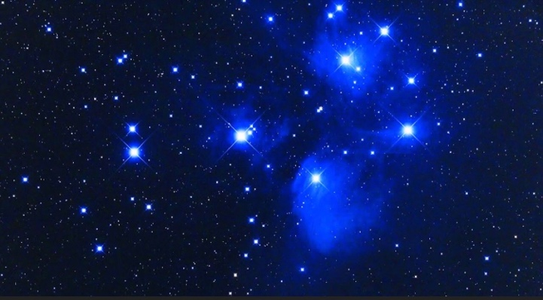
Welcome to the Cosmos
A Look into our Galactic Community…

We come from the Stars and most of us forget our cosmic roots when we get here. Our cosmic history is much more fascinating than wondering if UFOs are real or not. Most ancient civilizations knew of their connections to the Galactics which has been shown in petroglyphs, writings, art, books, and stories. It is time for this connection to be reconnected and our Galactic community is inviting us to join them.

We have entered the photon belt of the Pleiades with massive amounts of light energy streaming onto our planet and solar system. Earth is currently attempting to make a huge leap in consciousness as our world is shifting paradigms. It is no accident that our world is in chaos.

Join me for a class that will expand your consciousness and knowledge of many advanced extraterrestrial civilizations from my experiences and understandings. We will look deeply into who they are, where they are from, and why they are contacting us. Not all ETs are benevolent and we will discuss how to discern this as well as how to contact the benevolent ETs.

This will be a class that you can access from your own home on Zoom. It will be on September 12, 2021 from 2pm to 5pm EST. The cost is $88. It will be recorded if you cannot make it live. Come with an open mind and your questions. Looking forward to seeing you if you feel drawn.

You can sign up at www.hydeetehana.com/classes or email me at hydee@hydeetehana.com

*Zoom link will be sent out 2 days before the class*

