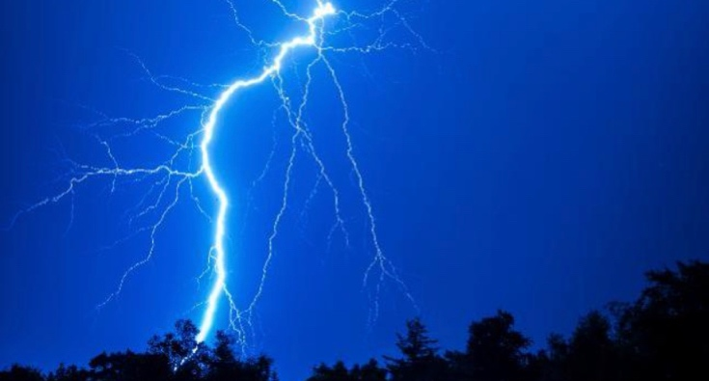
Awakening Your Power Within
Stepping into your Power…

Are you afraid of your power? Many of us are and many of us are cut off from our power believing that we have no control over our lives. What if you moved through your old beliefs and patterns that keep you stuck and in a place of victimhood? What if you realized that when you were born, most of us believed what our parents and society told us which completely cuts us off from our power within…our connection to Source.

We tend to look outside of ourselves and seek acknowledgement from others instead of from within. This ties us up to conforming to society and its belief systems. What if you followed your own guidance and listened to your heart where you know what is true for you instead of believing what is true for you?

It takes a strong person to look within themselves and discover the truth of who they are. Who are you? In this 3-day class, we will look at what is holding you back from uncovering your true self as well as much more. You are already whole and it is just peeling back those old layers that no longer serve you. This is a very expansive and transformative class which will evolve your consciousness.

This 3-day class is accessible from your own home on Zoom. It will be October 15-17, 2021. On October 15th and 16th, it will be from 2pm to 5pm EST. On October 17th, it will be from 1pm to 4pm EST. The cost is $333. It will be recorded if you cannot make it live. Come with an open mind and your questions. Looking forward to seeing you if you feel drawn.

You can sign up at www.hydeetehana.com/classes or email me at hydee@hydeetehana.com

*Zoom link will be sent out 2 days before the class*

