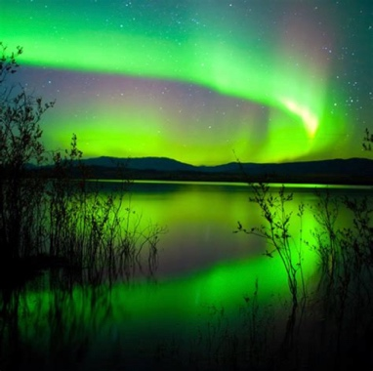
The Nature of Reality
Diving into consciousness, plasma, and more…

Are you wondering why are world seems to be in chaos and confusion? Do you know something is shifting, but you can’t put your finger on it? There is mass amounts of light energy streaming onto our planet and solar system as we have entered the photon belt of the Pleiades. This is bringing everything from the shadows into the light…including lies, secrets, and corruption.

We are currently attempting to make a huge leap in consciousness as our world is shifting paradigms from one of competition and exclusion to one of cooperation and inclusion. Consciousness is the feeling aspect of energy which is awake, aware, alive, and always listening.

Join me for a class that will expand your consciousness as we explore the nature of reality from a basis of plasma energy. The old Newtonian energy is of the old paradigm and we are stepping into a space based energy called plasma energy which will shift our world immensely. Other topics to be discussed will be time travel, timelines, teleportation, and multidimensionality.

This will be a class that you can access from your own home on Zoom. It will be on August 21, 2021 from 2pm to 5pm EST. The cost is $88. It will be recorded if you cannot make it live. Come with an open mind and your questions. Looking forward to seeing you if you feel drawn.

You can sign up at www.hydeetehana.com/classes or email me at hydee@hydeetehana.com

*Zoom link will be sent out 2 days before the class*

