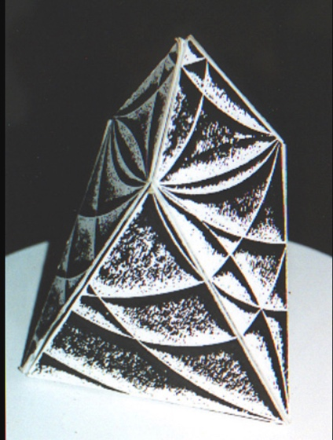
Our Multidimensional Heart
The Key to the Universe…

Rudolf Steiner said, “Humanity will evolve when we understand that the heart is not a pump.”
We are at a crossroads where the old world is falling away and the new world is coming online. This is a paradigm shift where the old ways no longer make sense as we have grown in our understandings. We are moving from the Newtonian ways of looking at the world to the plasma energies which lead us back to Source.

In this class, we will look at the old understandings of how our physical heart works to the new ways of understanding that our heart is not a pump. Why is this important? It is important because it shows us how space travel works and we are becoming a space-based society in the future. This also leads to medical breakthroughs and much more.

We will also look at the ancient understandings that our ancestors knew about the heart and how it is the key to everything. What did they know about becoming Eternal and how the heart brought them back to Source? Why are many of us cut off from our hearts and stay in our heads?

This will be a class that you can access from your own home on Zoom. It will be on August 28, 2021 from 2pm to 5pm EST. The cost is $88. It will be recorded if you cannot make it live. Come with an open mind and your questions. Looking forward to seeing you if you feel drawn.

You can sign up at www.hydeetehana.com/classes or email me at hydee@hydeetehana.com

*Zoom link will be sent out 2 days before the class*

